Lantern Making Instructions

- Select two sheets of construction paper of the same size, 1 for the outside frills (A) and 1 for the interior (B).
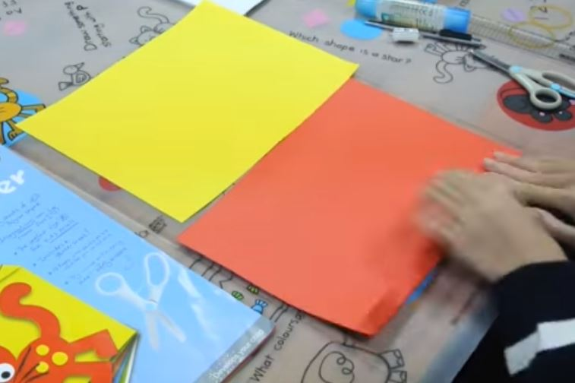
B
A

- Using sheet A, fold 2 cm down both sides lengthwise and 2 width-wise. Trim off the 2-cm width-wise fold.
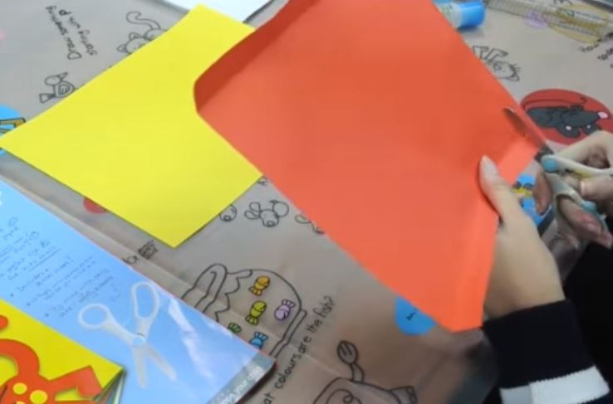

- Using a ruler, draw lines across the length of the paper (from the 2 cm lengthwise fold lines). Make sure that each line is approximately 2 cm apart. Using an X-acto knife, cut the paper at the lines.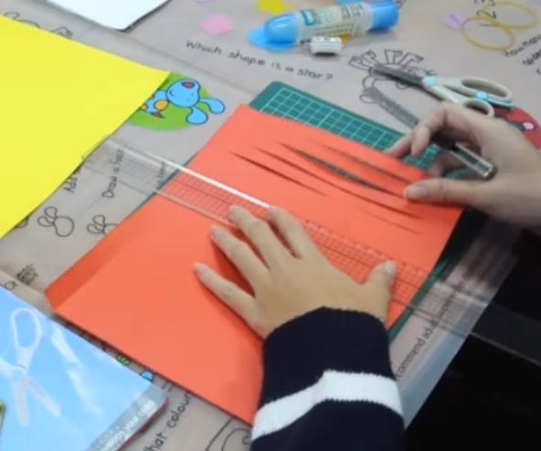

- Align the exterior paper with the interior paper and glue down one of the lengthwise sides.
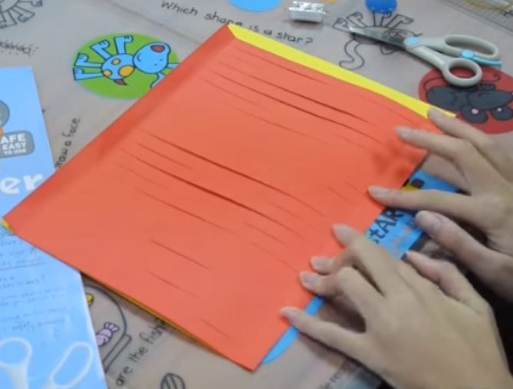

- Once glue has dried, align the unglued length-side sheet A 5 cm away from the edge of sheet B. Glue down this sheet A to sheet B.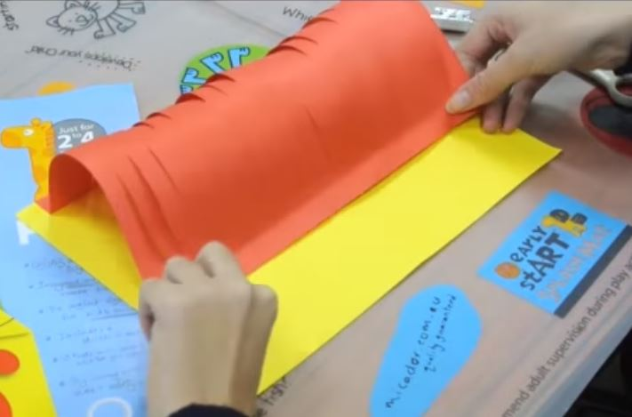

- At the exposed 5 cm of sheet B, cut lines across entire length to create frills.
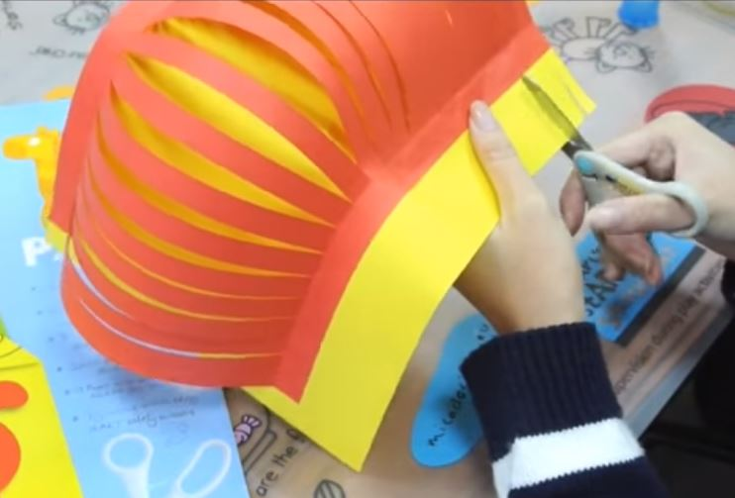

- Twist the paper into a circle, so that both width sides meet. Glue the width sides together
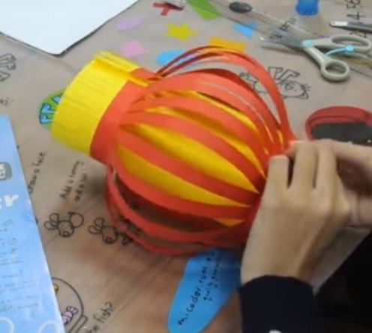

- Take strip of thicker paper that is longer than the diameter of your lantern, fold down sides and glue sides inside the lantern.
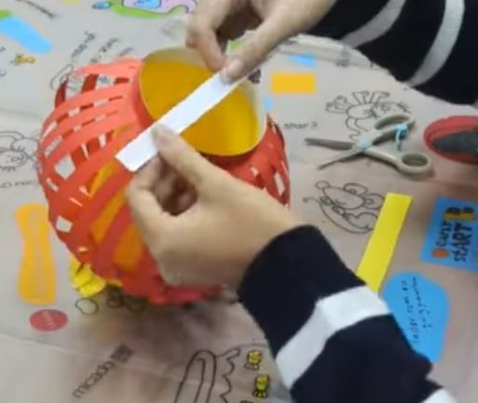

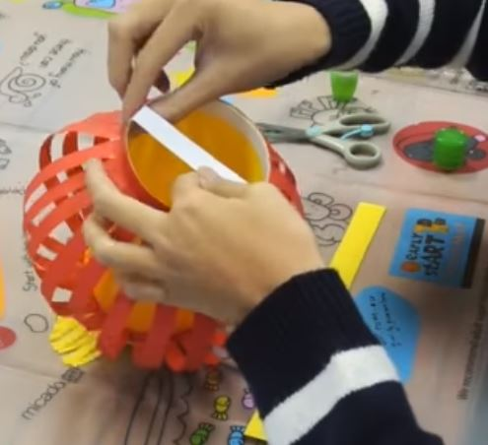

- Hang lantern light around this strip with string.

- Take a strip of paper and glue inside your lantern to form a handle.
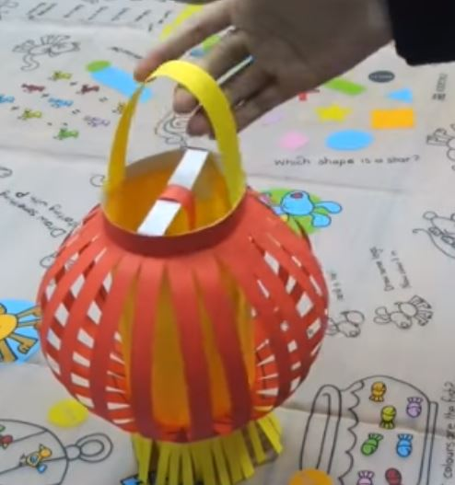

Happy Lunar New Year and enjoy your lantern!

Directions adapted from and screenshots taken from: https://www.youtube.com/watch?v=5qfsQhNs8bQ

